Accessibility Plan
St. Alban’s Catholic Primary School


Approved by: Dr. Lia Campos
Date: June 2025
Next review due by: June 2028

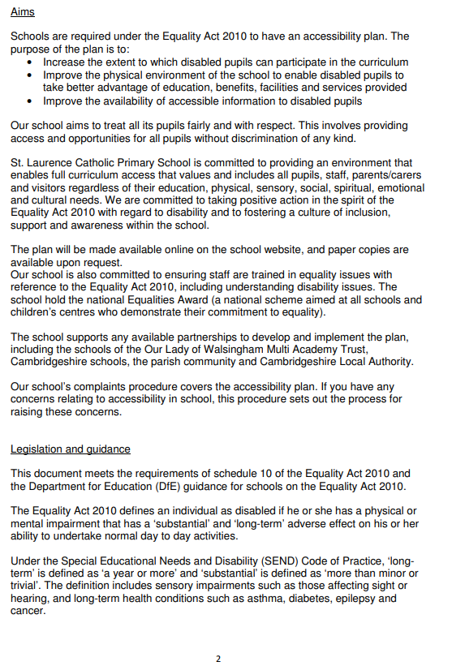
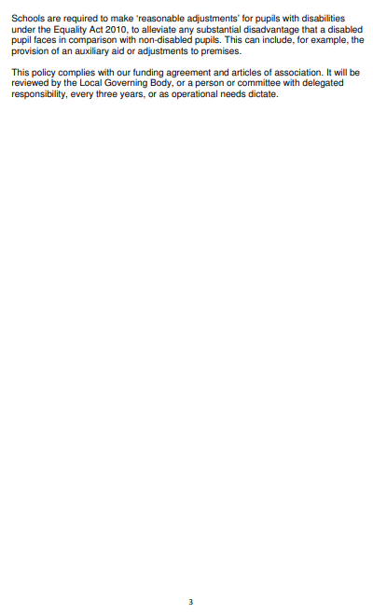
Aim | Current good practice | Objectives | Actions to be taken | Person/s responsible | Actions to be completed by | Success Criteria
Increase access to the curriculum for pupils with a disability. | St Alban’s offers an adapted curriculum for all pupils, according to individual needs and abilities. We use resources tailored to the needs of pupils who require support to access the curriculum. Curriculum resources include examples of people with disabilities. Curriculum progress is tracked for all pupils, including those with a disability. Targets are set effectively and are appropriate for pupils with additional needs. The curriculum is reviewed to ensure it meets the needs of all pupils. | Children with disabilities make at least good or better progress from their starting point in each year at St Alban’s Primary School. Children with disabilities make at least good or better progress from their starting point during their time at St Alban’s Catholic Primary School. | Monitoring of individual children’s progress through data analysis, Pupil Progress meetings Teaching and learning is adapted to suit the needs of individuals where appropriate. | Ex Headteacher  HOS  Inclusion Manager  Senior Leadership Team | Ongoing | Children with disabilities make good or better progress based on their individual starting points.
Aim | Current good practice | Objectives | Actions to be taken | Person/s responsible | Actions to be completed by | Success Criteria
Improve and maintain access to the physical environment | The environment is adapted to the needs of pupils as required. This includes:  • Corridor width  • Disabled parking bay.  • Disabled toilets and changing facilities. | Children with disabilities have access to manipulatives and resources to support their learning  A child who needs a wheelchair would have a Personal Emergency Evacuation Plan (PEEP) | All resources that children need in class are easily accessible.  Teacher to meet with School Office Manager to write PEEP | Class teacher and support staff  School Office Manager | Ongoing | Any pupil in a wheelchair can have access to classroom and toilet facilities through necessary reasonable adjustments.  Any pupil in a wheelchair can safely exit the school during an evacuation with support from an adult
Aim | Current good practice | Objectives | Actions to be taken | Person/s responsible | Actions to be completed by | Success Criteria
Improve the delivery of information to pupils with a disability | St Alban’s uses a range of communication methods to ensure information is accessible. This includes:  • Internal signage  • Large print resources  • Pictorial or symbolic representations  • Visits from external specialists e.g. hearing, sight | Continue to work with outside agencies who offer support to ensure effective communication methods and sharing of information. | Arrange times to meet with specialists throughout the academic year. | Inclusion Manager/SENCO | Ongoing | Children with disabilities will continue to have important information supplied to them in a way which meets their needs.
Monitoring arrangements
This document will be reviewed every three years, but may be reviewed and updated more frequently if necessary. It will be approved by the Local Governing Body of St Alban’s Catholic Primary School.

Links with other policies
This accessibility plan is linked to the following policies and documents:
• Safeguarding and Child Protection policy
• Inclusion policy
• Health and safety policy
• Intimate Care policy
Review: Policy discussed and agreed with Governors in June 2025
Next review by Governors: June 2028

