Behaviour Policy and Anti-bullying policy

ST ALBAN’S CATHOLIC PRIMARY SCHOOL


Christ Be Our Light

“Forming confident children, grounded in Humility, Bound by Respect”

Approved by: CoG Stefania Deidda
Date: September 2026
Next review date: September 2027




BEHAVIOUR AND ANTI-BULLYING POLICY

"Do to others what you would have them do to you." Matthew 7:12

Section 1

Introduction

At St Alban’s Catholic Primary School, we seek to form confident children, grounded in humility, bound by respect. This document is a statement of the aims and strategies for developing kindness, respect and positive behaviour within our school community. An effective Behaviour Policy is one that aspire to lead children towards kindness, high self-esteem, self-discipline and, ultimately, self-regulation. Consequently, kindness, respect and good discipline derives from positive relationships and from setting consistent expectations of good behaviour.

School Mission Statement
Kindness, along with our school motto, Christ Be Our Light, is always at the centre of all that we do. Everyone at St Alban’s is expected to maintain the highest standards of personal conduct, to accept responsibility for their behaviour and encourage others to do the same. This is fundamental to our vision for all in our school community as we aspire to form confident children, grounded in Humility, bound by Respect. St. Alban’s Catholic Primary School is committed to creating an environment where exemplary behaviour is at the centre of productive learning. Everyone is expected to show kindness and maintain the highest standards of personal conduct, to accept responsibility for their behaviour and treat others the same as they wish to be treated themselves. This is fundamental to the St Alban’s vision for everyone within our school community.

Core values and beliefs
At St Alban’s Catholic Primary School, we believe that every child is truly a gift from God, made in his image and likeness and therefore entitled to be valued and respected as a unique individual. Through partnership with our parents, working together in a mutually supportive relationship, the school aims to make this mission statement our goal.

Aims of our Behaviour Policy

At St Alban’s, we believe all children should be explicitly aware of the standards of behaviour expected of them and with guidance and nurturing, eventually take responsibility for promoting these standards at our school. By encouraging and rewarding positive behaviour and kindness, we promote good relationships throughout the school built on kindness, trust and understanding, and through the use of this policy we support our children in developing a high level of individual and social responsibility.

To create a culture of exceptionally positive behaviour where optimal learning takes place.
To help and support children take control over their behaviour and be aware of the agreed school consequences for not displaying school expectations.
To build a community which values kindness, care, good relationships and empathy for others.
- To create and sustain a kind, fair, and consistent environment for all.
- To foster a culture of mutual respect derived from kindness.
- To develop in everybody an understanding of the needs of others.
- To positively promote the children’s sense of pride and belonging to the St Alban’s school community.
- To have a clearly structured policy that is applied throughout the school in a consistent manner.

Purpose of this policy
To provide simple, practical procedures for parents, staff and children to:

• Recognise and model positive behaviour expectations
• To provide a framework to ensure all members of the St Alban’s community are treated with kindness and respect and staff are given clear expectations and guidance on how to consistently ensure this
• Positively reinforce and celebrate, through praise and rewards, behaviour expectations
• Promote self-esteem and self-regulation
• Teach appropriate behaviour through restorative practice and discussions

Code of Conduct & Rewards – Rights and Responsibilities

We all have the right:
1. To receive an engaging and inspiring education, which is broad and balanced.
2. To be provided with a safe and secure learning environment.
3. To be listened to and to have opportunities to express opinions.
4. To have access to good quality resources.
5. To have teachers and adults who display kindness and are consistent and fair.
6. To have good relationships and to be able to work cooperatively with others.

We all have the responsibility:
1. To work and learn to fulfil our potential by always trying our hardest in everything we do.
2. To respect and look after our classroom, class resources and school environment.
3. To ask for permission before using or touching the belongings of others.
4. To be ready to engage with the learning.
5. To listen to, and be respectful of, the opinions of others.
6. To look after each other and ensure our school environment is safe.

For consistency and clarity, St Alban’s has three simple expectations. They are:

‘Be Ready, Be Respectful, Be Safe’
We recognise that a clear structure of predictable outcomes has the best impact on positive behaviour and an environment based on mutual respect. Our principles set out clear boundaries, relentless routines and visible consistencies that all children and staff follow.

Our school approach is based on the work of Paul Dix, former educator and Behaviour Management specialist, and his book ‘When the adults change, everything changes’. Positive behaviour is recognised sincerely and derived through ‘kindness’ rather than just rewarded. Children are praised publicly and reminded in private. The ‘behaviour is addressed, not the child’ (2017). Dix’s findings have shown that ‘the shift in culture and climate’ actually derives from ‘adults changing their behaviour and sustaining that change’ (2017) and as a whole school we always revert back to the positive behaviour that has been previously seen. Additionally, we follow the approach of ‘First attention to Best Conduct’ and use ‘Scripted restorative follow-up’ discussions to support child understand how they can choose better choices.

‘Be Ready, Be Respectful, Be Safe’ can be applied to a variety of situations and are taught and modelled explicitly. We have only three to ensure they are easier for children, staff and parents to remember and follow. They are derived from the following five pillars.

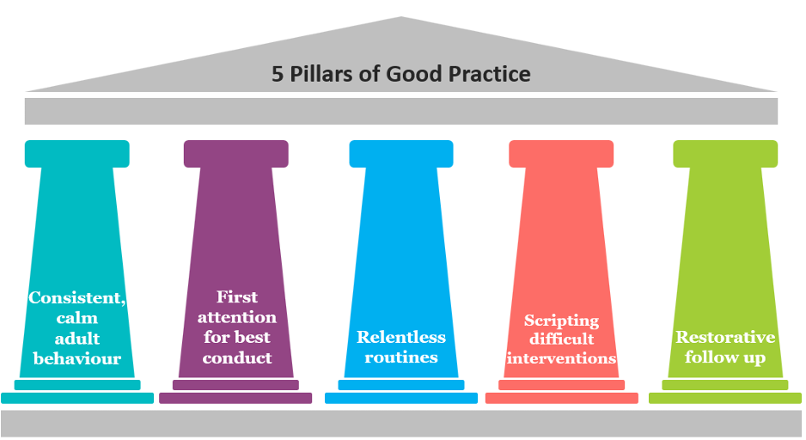

These pillars underpin our practice at St Alban’s with regard to maintaining good or better standards of behaviour. It creates a culture that all staff ‘are here’ and all speak of ‘mutual respect, support and a willingness to help, not judge.’ This helps to make everyone at St Alban’s feel valued and supports us to let Christ be our Light.

Our St Alban’s consistency in practice

1. Meet and greet children by name each morning
2. Refer to Ready, Respectful, Safe for how we ‘do things at St Alban’s Catholic Primary’
3. Consistent positive reinforcement (in public)
4. Consistent consequences (followed by all staff)
5. Consistent modelling of positive behaviours by all they support building relationships
6. Plan lessons that engage, challenge and meet the needs of all children
7. Be calm, positive and consistent when going through the behaviour pathway
8. Seek to identify triggers to prevent escalation
9. Follow up every time
10. All staff to consistently ensure they never ignore or walk past children who are not behaving in line with the school expectations

Our School Rules: Ready, Respectful, Safe
Be ready
- We arrive at school on time, all the time.
- We wear our uniform with pride and have the correct clothing for different school day (PE).
- We participate fully in lessons and demonstrate positive learning behaviours – resilience,
perseverance, fortitude, curiosity and active listening,

Be respectful
- We always listen when others are speaking.
- We are polite, kind and display good manners to all that we meet.
- We respect difference and know that everyone is treated fairly and given what they need.
- We actively respect and look after our school environment, equipment and encourage others to do so.
- We display positive learning behaviours – collaboration, kindness, active listening, support and active engagement.

Be safe
- We respectfully follow instructions – first time, every time.
- We always stand up to unkindness of any sort.
- We always walk sensibly and safely around the school.
- We stay safe online, inside and outside of school.
- We know who to approach to seek help and support.

Our Rules | Visible Consistencies | Recognition & Praise
1. Be ready  2. Be respectful  3. Be safe  *Every day is a fresh start for our children.  *Staff will look for and celebrate positive behaviours. | 1. Daily meet and greet  (in playground or in classroom doorway)  2. Wonderful walking (throughout all areas of the school during all parts of the day) | 1. Recognition praise board earnt by RRS & kindness (class termly reward – agreed with teacher)  2. Stickers – rewarded for RRS & kindness  3. House points linked to RRS– termly award for house (chosen by Teacher & agreed by KS Pleads)  4. Certificates (HT/Kindness/RRS). One certificate for a child each week.  HT certs: linked to all aspects of school (every 2 wks)  Kindness, RRS weekly:  Lunchtime award weekly: Lunch team to choose 1 child for the week RRS (extra award)  5. Sent to other staff members for praise including HOS/EHT  6.Celebrated in class/assemblies/school communication (newsletter/social media)  Above & beyond:  6. Teachers make a brief positive weekly Friday celebration phone call (this can be playground discussion) to deserving child. HOS/EHT to choose one child a week to call to reinforce.

Relentless Routines
Praise in Public (PIP)  Remind in Private (RIP) | *Wonderful walking around school  *Legendary line-ups  *Tremendous transitions | Consistent language  Consistent use of the recognition praise board (golden ladder)  Consistent sitting (in assemblies and class)  Lining up: Morning, break, lunchtimes, entering and exiting class, on trips.  Transitions: Transitioning to next lesson/assembly, moving from classroom to classroom, classroom to playground, playground to lunch hall etc.

Restorative actions & scripts
Consequence for actions
Every day is a fresh start for all children. The intention is for children to be recognised for positive behaviour as often as is possible. We operate a advanced system when managing low-level disruption in class. Children will receive a discrete verbal warning, a second discrete verbal warning and then teachers will use triage to decide on the next course of action. A restorative discussion will take place, using the guidance and the member of For example, reflective conversation and missing a few minutes of break. If more severe, a whole break or some or all of lunchtime may be withdrawn from the child’s routine. The use of an advanced approach should be swift and appropriate for the child, to be used at the teachers’ discretion (e.g. reminder of rules at the end of the lesson/break time). Often, the conversation with the child will be the consequence.
All staff to use gentle approach: use child’s name, child level, eye contact, deliver message calmly
1.REMINDER:

I noticed you chose to …. (notice behaviour)
This is a reminder that we need to Be (Ready, Respectful, Safe)
You now have the choice to make a better choice
Thank you for listening
Example –‘I notice that you are running inside school. You are breaking our school rule of being safe. Please walk. Thank you. Enjoy the rest of lunchtime.’
2.WARNING: Child must wait behind for one minute for reminder of RRS.

I noticed you chose to …. (notice behaviour)
This is the second time I have spoken to you.
You need to speak to me for 2 minutes after the lesson.
If you choose to break the rules again you leave me no choice but to ask you to sit in a quite area.
Do you remember when ……. (model of previous good/positive behaviour)? That is the behaviour I expects from you today. Think carefully. I know that you can make good choices. Thank you for listening carefully to what I am saying.
Example – ‘I have noticed that you are not ready to do your work. You are breaking the school rule of being ready. You have now chosen to catch up with your work at playtime. Do you remember that yesterday you started your work straight away and got it finished? This is what I need to see today. Thank you.’
3.CALMING TIME: Removed from normal seating position to reflect on behaviour and the school expectations (RRS & kindness). Restorative conversation to take place at the end of the lesson or breaktime.

I noticed you chose to …. (notice behaviour)
You need to 1.Sit in a quiet area within the class. 2. Sit outside of the class. 3. Sit in another class.
Playground: 1.Stand with an adult 2.Sit close to duty adult 3.Go to wait outside the office.
I will come and speak to you in 2 minutes.
Thank you.
Example – ‘I have noticed you chose to use rude words. You are breaking the school rule of being respectful. You have now chosen to go and sit in a quiet area. I will come and speak to you in a few minutes time. Thank you.’

The behaviour of another child should not be discussed to another adult in front of the child.
4. Triage - Restorative steps. Before choosing the next steps, members of staff will have time to think about the child’s behaviour before choosing the appropriate actions. If our school expectations aren’t followed the teacher will decide the relevant consequences from the following:
- Loss of break time - missing some of break time to sit quietly and think about my choices and or complete a restorative contribution (tiding an area of the classroom/corridor/school hall/library)
- Loss of lunch time – to complete tasks to support the school
- Loss of right to join the activities at break or lunchtime - stepping away from playground games or clubs if I am not playing safely or respectfully but allowed outside.
- Reflection time during school hours - spending quiet time completing the school’s Reflection Sheet with to think about how their actions affected others.
- In line with Catholic Social Teaching, actively showing my positive behaviours (and kindness) by supporting our school community. This includes, supporting lunch service by helping others at (inside the hall and on the playgrounds) by helping to tidy parts of the school, tidying playground equipment, maintaining green areas of the school.
- Being put on a behaviour agreement (if required), as per appendix 2.
- If behaviour is persistent or serious, a child can be removed from a whole house or whole class termly rewards, sporting events, special assemblies, trips, events or elements of school themed weeks. *KS Phase Lead and HOS approval needed for this to ensure all staff are aligned.

To help me show Respect and rebuild positive relationships, these steps will also happen:
- A Restorative Conversation: Having a quiet, calm chat with my teacher at the end of the lesson to explain what happened and how to move forward positively.
- Fixing what was broken: Helping to tidy up resources, clean a workspace, or repair property if my behaviour caused a mess or damage.
- An authentic apology: Writing or saying a sincere apology to show my classmates or staff that I value them.
- A Restorative Circle check-in: Joining a small support group or circle with a teacher to talk through problems and rebuild trust in the classroom.
- A fresh start: Knowing that once I have made things right, I will receive a complete fresh start from the adults around me.
5.FOLLOW UP, REPAIR AND RESTORE:
1.What happened? (Neutral, dispassionate language)
2.What were you feeling at the time?
3.What have you felt since?
4.How did this make people feel?
5.How can we do things differently in the future?

Classroom Support Plan & Restorative Conversation
All St Alban’s staff are expected to follow the guidelines contained in the behaviour and discipline matrix. In every incident, the unacceptable behaviour will be explained to the pupil and they will have the opportunity to explain their actions.
*adults will follow responses as far as is deemed appropriate.

For further information, please see the Classroom Support Guide in Appendix 3.
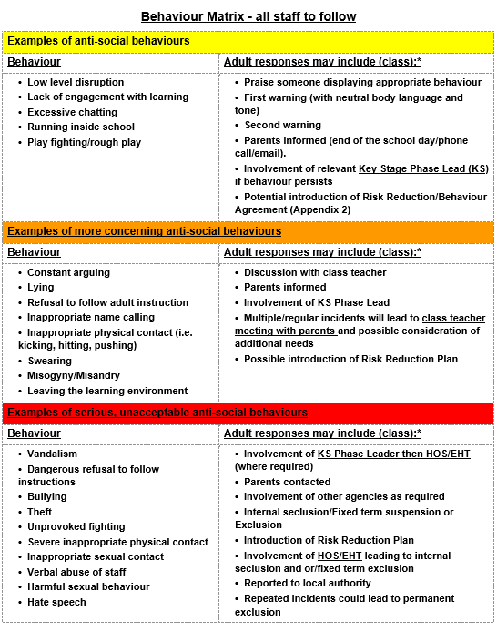
Incidents of extremely inappropriate behaviour and suspensions/exclusions

At St. Alban’s Catholic Primary School, suspensions/exclusions are used as a last resort and each case is treated on its merit and will be treated equally. The decision to exclude a pupil will only be taken in the following circumstances:
● In response to a serious breach of the school’s Behaviour Policy;

● If allowing the pupil to remain in school would seriously harm the education or welfare of the pupil or others in the school.

This could take the form of internal seclusions where the child is kept apart from their peers for a set period of time, but remains within the school premises. A child that is demonstrating extreme inappropriate or dangerous behaviour at lunchtimes may be subject to lunchtime exclusions whereby the parent/carer is required to withdraw the child from the school premises over the lunchtime period. Pupils may also be educated off-site with alternative provision for a set period of time, depending on the severity or frequency of the behaviour.

This action is taken with the agreement of the parents/carers. If there is disagreement between the school and parents/carers in relation to this action and parents/carers decide not to take their child to the alternative provision and decide to keep their child at home then this will be recorded as an unauthorised absence. For more information on suspensions and exclusions, please refer to the Exclusions Policy.

Extracurricular
For extracurricular activities, either on site or off site where the children are under the lawful control of the staff member, the same rules apply as in the classroom. Misbehaviour will result in the child not being able to join in the activity for the rest of the session. Persistent misbehaviour will result in the child being excluded from any further involvement in the club with no refund of money. Please see the appendix for the guide for leaders of school clubs.

Use of reasonable force and other physical contact
Occasionally situations may arise in which physical restraint may be required. A member of staff, may use such restraint as is reasonable in the circumstances for the purpose of preventing the pupil from doing (or continuing to do) any of following-
• causing personal injury or damage to property
• engaging in any behaviour prejudicial to the maintenance of good order and discipline at the school or among any of its pupils (Please see Use of Reasonable Force Policy).
Practical methods to defuse the situation will be considered before restraint is used – keeping calm, offering verbal prompts, guiding, steering or retreat (if appropriate). In a serious incident leading to physical restraint or where physical restraint has been resisted, parents will be informed.

Confiscation of Personal Items
Occasionally situations may arise in which physical restraint may be required. A member of staff, may use such restraint as is reasonable in the circumstances for the purpose of preventing the pupil from doing (or continuing to do) any of following-
• causing personal injury or damage to property
• engaging in any behaviour prejudicial to the maintenance of good order and discipline at the school or among any of its pupils
(Please see Use of Reasonable Force Policy)
Practical methods to defuse the situation will be considered before restraint is used – keeping calm, offering verbal prompts, guiding, steering or retreat (if appropriate). In a serious incident leading to physical restraint or where physical restraint has been resisted, parents will be informed.

Partnership With Parents
Our Home School Agreement clearly sets out our expectations for behaviour.
Parents and school staff will work together to reward appropriate behaviour and bring sanctions to bear for inappropriate behaviour. Clear communication between the school and home is essential for the mutual support and co-operation. Home/School Books detailing behaviour will be used where there is frequent inappropriate behaviour by a child.

Exclusion of a Pupil
At St Alban’s exclusion is seen as the last resort, after all other attempts to modify behaviour have failed. Exclusion serves several purposes:
• To act as a consequence of the chosen poor behaviour and reinforce, in the mind of the child, the seriousness of the behaviour.
• To maintain high standards of behaviour in school.
• To secure the well-being and entitlement of other children and staff in school.

Exclusions may be for either a fixed term or permanent. It is the Head of School’s responsibility to decide whether a child should be excluded. Exclusions will only happen in response to a serious breach, or series of breaches of the school’s Behaviour Policy or where the alternative forms of behaviour management have been shown to have failed.
If the Head of School decides to exclude a child, the parents will be informed as soon as possible and issued with a letter giving details of the incident and setting out their legal rights regarding exclusion. Appropriate work will be set for the duration of a fixed term exclusion.
Details of exclusion procedures are kept in the school office.

Misbehaviour outside school Premises
Schools have a statutory power to regulate the behaviour of pupils when off school premises and not supervised by staff. Schools can impose sanctions when the pupil returns to school or under the lawful control or charge of a member of staff. All educational visits will include clear statements to parents and pupils about behaviour standards and processes.

Section 2: Bullying

At St. Alban’s Catholic Primary School, we do not tolerate bullying of any kind, including incidents affecting members of staff. Please see the anti-bullying section below. Please see the Safeguarding and Child Protection Policy in relation to responding to allegations of sexual harassment or sexual violence.
Aims of our Anti-Bullying Policy
In order to prevent bullying and build an inclusive learning environment for all, St Alban's Catholic Primary School promotes an ethos centered on explicit core aims. These aims connect our everyday actions directly to our overarching commitment to individual emotional development and safety.
1. To uphold caring values; we all aim to treat each other well.
This embodies our promise to be bound by respect, establishing that treating others well is a universal, non-negotiable standard for everyone in our school community. It connects to the core practice of relentless, unconditional care and adult-led emotional consistency, where adults model calm kindness so that children feel safe enough to mirror it.
2. To make children aware of the behaviour which is expected of them.
This is essential for forming confident learners. Clarity eliminates anxiety, and children build genuine confidence when they know exactly how to succeed. It relies on visible consistencies and clear, simple rules—Ready, Respectful, Safe—ensuring that school expectations are clear, simple, and constant.
3. To include discussion/work on bullying in class discussions and assemblies.
This ensures our children grow grounded in humility. Openly reflecting on social impact in classes and assemblies teaches children to look beyond themselves and consider how their choices affect their classmates. This shifts the focus toward preventative, relational practice by addressing topics openly before issues escalate.
4. To foster kindness and positive reinforcement through example.
This shows our community is bound by respect through actions, not just words. Staff model the standard first because children learn respect by seeing adults treat everyone with dignity. This prioritises giving our first attention to the best conduct, celebrating positive choices publicly while managing negative behaviour quietly and privately.
5. To encourage good manners and the reasons for this.
This helps children grow grounded in humility, as good manners demonstrate that we value other people's space, time, and feelings. This moves past simple compliance toward shared social values, teaching the deeper reasons behind manners so children have a meaningful rationale to regulate their own behaviour.
6. To encourage children to take responsibility for themselves and for others.
This is a vital part of forming confident learners. True confidence comes from taking ownership of mistakes, learning from them, and taking active care of vulnerable peers. It is driven by a restorative approach where, if rules are broken, the focus is on repairing harm and actively restoring the balance.
7. To value individuality and nurture the emotional life of our children.
This creates an environment for forming confident learners, grounded in humility, where children are confident in their own identity while valuing the uniqueness of others. It recognises that all behaviour is communication, meaning sustainable change happens when we treat children as individuals, understand their specific needs, and protect them from public shame.

What is Bullying?

Bullying is behaviour by an individual or a group, repeated over time, that intentionally hurts another individual or group either physically or emotionally.

- It is deliberately hurtful behaviour.
- It is repeated often over a period of time.
- It is difficult for those being bullied to defend themselves.
It can be:
- Short term or continue for years.
- Physical.
- Verbal – name calling, malicious gossip.
- Just a look.
- Overt.
- Subtle intimidation – coercing the victim into acts which they do not wish to do.

The five main types are:
- Physical: Hitting, kicking, tripping, pushing, or intentionally damaging or taking belongings.
- Verbal: Name-calling, insulting, identity-targeted teasing, or using malicious gossip.
- Prejudice-Based / Discriminatory: Targeting an individual based on identity or protected characteristics. This includes racist, faith-based, sexist, homophobic, or disability-related remarks.
- Indirect / Emotional: Spreading nasty stories, mimicking, or intentionally excluding someone from social groups to cause psychological distress.
- Cyberbullying: The inappropriate use of the internet, social media, messaging apps, mobile phones, smart devices, or online gaming environments to harass others. The school formally addresses cyberbullying as a child-on-child abuse issue across three primary, annually reviewed documents: the Acceptable Use Policy, E-Safety Policy, and the IT Code of Conduct.

Differentiating Play from Bullying:
Boisterous, high-energy play is a natural part of primary school childhood. However, social friction crosses the line into bullying when it features rough, intimidating behaviour, persistently spoils other children’s activities, or subjects a child to repeated acts that cause ongoing misery over time.

Staff Vigilance and Identification
Individual staff members take seriously their responsibility to provide relentless, unconditional care both inside and outside the classroom. Driven by our school vision, staff remain highly watchful for changes in behaviour, recognizing that all behaviour is a form of communication.
Staff actively note and report indicators of distress, including:
- Social Isolation: A child being left out or withdrawing from peer groups during lessons or playtime.
- Withdrawn Behaviour: A sudden drop in confidence, change in mood, or quietness.
- Declining Academic Performance: An unexpected struggle with focus, engagement, or classwork.

Safe Reporting and Open Communication
To build confident learners, staff create a safe environment where children know exactly how and whom to tell if they are worried, eliminating the fear of peer retaliation. Through class discussions, RE, and assemblies, staff explicitly teach children that reporting harm is an act of care, reinforcing our key community message:
- All are expected and encouraged to tell: Speaking up protects our community and helps us look out for one another.

Agreed Procedures for Staff Response
When bullying is suspected or has occurred, staff respond calmly, predictably, and consistently, ensuring children are protected from public shame and that relationships can be safely repaired.
- Take the incident seriously: Listen calmly to the child without immediate judgement, ensuring they feel heard, valued, and safe.
- Take action as quickly as possible: Intervene immediately to stop any harmful behaviour and establish safety for everyone involved.
- Inform Leadership: The Head of School must be informed immediately, and a formal incident report must be completed on the school tracking system.
- Alert colleagues: Share relevant details confidentially with the wider staff team so that all adults can maintain a high level of vigilance and care across the school.
- Partner with families: Inform parents/carers promptly, focusing on collaboration, transparency, and how the school and home will work together to support the children.
- Maintain secure logs: Detailed, objective records of all bullying incidents and actions taken will be securely maintained by the Senior Leadership Team.

Restorative Strategies for Overcoming Bullying
Our strategies focus on restoring community balance, teaching accountability through humility, and rebuilding trust through respect.
- Policy-driven consistency: All staff use our Behaviour Policy consistently to provide predictable routines and regular reviews.
  - A trusted adult will be agreed upon in partnership with the SLT, the child, and their parents/carers.
  - The trusted adult will conduct brief, private, and supportive check-ins (at least once a week) with the child who has experienced the bullying behaviour.
  - During these check-ins, the mentor will guide the child through a reflective questionnaire to review the past week. The Head of School will maintain regular contact with parents/carers to review progress and ensure ongoing reassurance.
- Proactive Classroom Education: Develop explicit classroom activities in relevant lessons to actively combat bullying. Staff will use drama, role-play, and structured games to build empathy, while explicitly reminding children that our community is bound by respect and does not tolerate behaviour that hurts others.
- Structured Playground Environments: Because unstructured times require the highest level of adult presence and care, the school will offer positive, organized alternatives during breaks:
  - Quiet areas: Supervised, calm spaces for children who prefer peaceful social interactions.
  - Playtime equipment boxes: Structured games and resources to encourage cooperative and inclusive play.
  - Fixed play equipment: Well-managed physical activities that promote turn-taking, patience, and team confidence.

APPENDIX 1

St Alban’s pupil reflection sheet

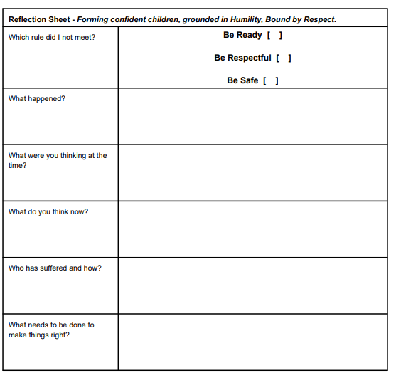

APPENDIX 2
Behaviour agreement

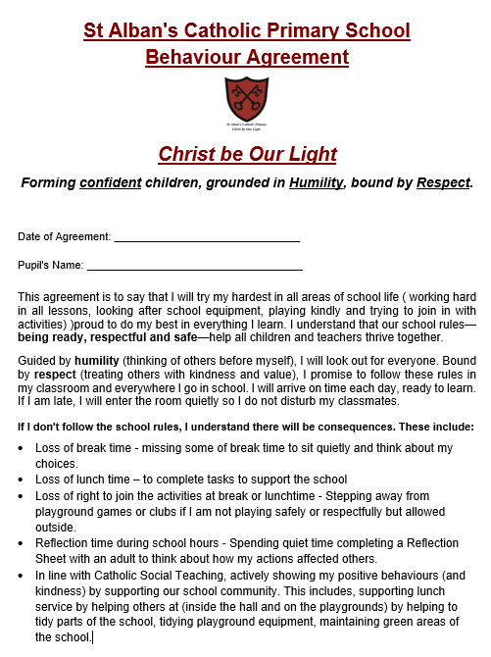

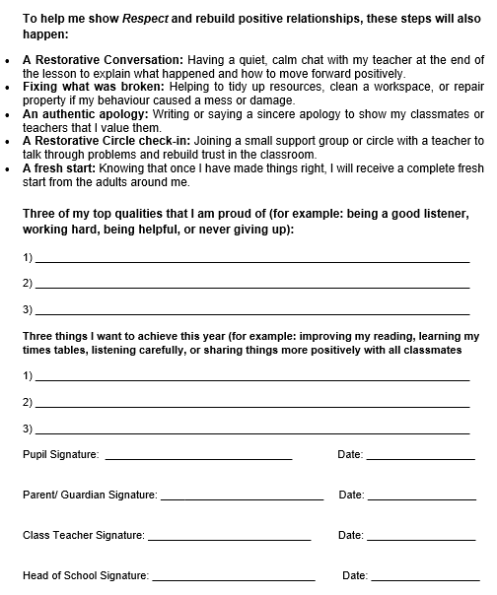

APPENDIX 3

Staff Behaviour Response Checklist: 5-Step Escalation
Always use a gentle approach: use the child's name, get down to their physical level, maintain eye contact, and speak calmly.

STEP 1: FIRST WARNING
- Action: Private verbal or non-verbal rule prompt at the child's eye level.
- Staff Focus: Notice the behaviour quietly to avoid a public power struggle.
- Key Phrase: "I noticed you chose to... This is a reminder to be [Ready / Respectful / Safe]. Thank you."
🛡️ STEP 2: SECOND WARNING
- Action: Explicitly state the rule break and issue a post-lesson instruction, then walk away immediately to give them take-up time.
- Key Phrase: "This is the second time I have spoken to you. Please speak to me for 2 minutes at the end of the lesson. Thank you."
🛡️ STEP 3: CALMING TIME
- Action: Move the child to a different sitting position to break the circuit (e.g., quiet table in class, outside the room, or in a partner class).
- Playground: Stand with an adult, sit on a bench, or wait outside the office.
- ⚠️ Rule: Do not describe a child’s behaviour to another adult in front of them.
🛡️ STEP 4: LOSS OF BREAK TIME
- Action: Retain the child for a set portion of their next break to hold them accountable.
- Task: The child completes the Restorative Reflection Sheet matching their Key Stage time limit (Max 5 mins for KS1, 10 mins for Lower KS2, 15 mins for Upper KS2).
🛡️ STEP 5: RESTORATIVE DISCUSSION
- Action: Meet calmly at lunchtime to work through the 5 restorative prompts and repair the relationship before the afternoon sessions begin.
- The 5 Prompts:
  - What happened?
  - What were you thinking at the time?
  - Who was affected and how?
  - What do you think now?
  - How can we make things right?

Step | Behaviour | Restorative action | Procedure

APPENDIX 4: Behaviour management expectations for school clubs

St Alban’s Catholic Primary School

Welcome to St Alban’s Catholic Primary School. As a visiting educator, you are a valued part of our learning community. To ensure consistency for our children, we ask that you follow these protocols when managing disagreements or conflicts between pupils. In the event of any serious incidents, please follow the following:

1. De-escalation and Immediate Response
- Stay Calm: Model the regulated behaviour we expect from our pupils. Use a neutral, quiet tone to de-escalate tension.
- Safe Space: If a conflict arises, physically separate the pupils involved. Allow a "cooling-off" period before attempting to discuss the incident.
- Safety First: If you feel a situation is unsafe or escalating beyond your control, send a reliable pupil to the nearest classroom or the Main Office to request a member of the Senior Leadership Team (SLT).
2. Prioritising ‘Pupil Voice’
We use a Restorative Approach to help children understand the impact of their actions and find a way forward. When the children are ready to talk:
- Listen to Both Sides: Give each child a chance to speak without interruption.
- Restorative Questions: Use open questions such as: “What happened?”, “What were you thinking at the time?”, and “How do you think [Name] is feeling?”
- Resolution: Ask the children: “What needs to happen to make things right?” Focus on repair rather than just punishment.
3. Recording and Sharing Information
It is vital that the school has a complete picture of a child’s day.
- Report to the Class Teacher: Before leaving the site, you must provide a brief verbal or written hand-over to the child’s regular Class Teacher or the School Office.
- Fact-Based Records: If you are asked to complete a written incident slip, please record only the facts (what was seen and heard) rather than your personal opinions or assumptions.
- Safeguarding: If a conflict suggests a deeper concern (e.g., bullying, peer-on-peer abuse, or a disclosure), you must speak to our Designated Safeguarding Lead (DSL) immediately before leaving the premises.

4. Communication with Parents
To maintain a consistent home-school relationship, we manage parental contact centrally:
- School-Led Contact: Generally, the Class Teacher or SLT will decide if and when to notify parents about a conflict.
- No Direct Contact: Please do not contact parents directly (via phone, email, or at the school gate) regarding behavioural incidents unless explicitly directed to do so by the Headteacher.

